Capstone Proposal
Natalie Rowland

October 2014
Engineering Design and Development
Capstone Proposal
Capstone Project
My capstone is to promote STEM within the Waxahachie community, by demonstrating the applications of STEM to young girls I tutor, and influence them to enjoy scientific and mathematic applications.
Passion Behind Capstone Project
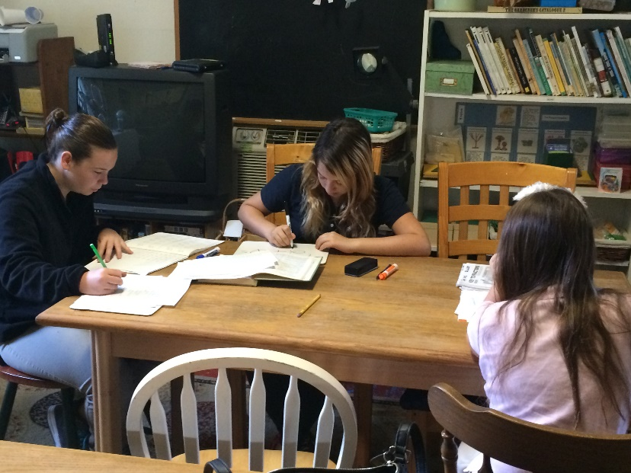
I will be graduating in December of 2014, and so I needed a capstone which was compliant with my schedule. Since I’m going to major in physics at college, a STEM based capstone was a great fit. This also worked well with activities I was already participating in, such as being a volunteer math tutor for girls at a local school, the Pettigrew Academy, pictured here. I also enjoy working with graphic design, and so making posters for the community also worked well under the circumstances.
Benefits
- This project adds more STEM interaction to my portfolio
- This project allows me to focus on the tutoring aspect of my time while having multiple purposes
- This project also includes a scholarship contest which I’m entering
- This prepares me for more STEM activities once I’m at college
Milestones
- Begin working with my girls (9/2)
- Test the girls skill levels (9/9)
- Create custom plan around each girl’s needs (9/11)
- Work with girls to improve their skills (September and October)
- Have a mid-point test to assess skills(11/4)
- Reassess the progress of the girls (11/5)
- Introduce the altered plan to the curriculum (11/6)
- Begin phasing in next year’s tutor (11/18)
- Get girls final scores for their packets (12/2)
- Get reflections from girls (12/9)

Final Product
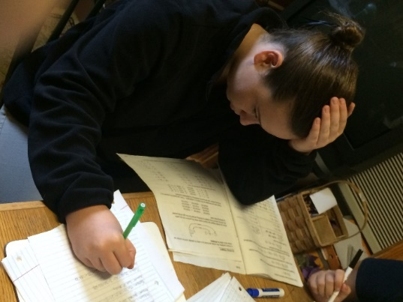
My final products are short reflections from the children I tutor about where they felt they were before I came, how the experience was during my tutoring, and how they feel after I’ve finished my semester of assistance.
Professional Mentors Involved
I don’t have a mentor, however, the leader of the school I tutor at, Kim Bauman, helps develop my plans through aiding the children when I’m not there, and guides me through the process of helping all of the girls, even with their varying ages and places in mathematics, and I also have contact with a civil engineer and member or the water management board of Fort Worth, whom I speak with often.
Weekly Commitment
I go to tutor the girls twice a week, Tuesday and Thursday from 1:30 – 3:00. During this time, each of the girls gets approximately 30 minutes of one on one tutelage for questions and a “grading” period.
Audience
The parents of the girls and the girls themselves are my audience, and I’m attempting to show them that math can be fun and fruitful while making them enjoy themselves. Another goal was to improve their general understanding of math, to prep and assist them in their readiness for their grade level and expected skills they’d need.
Contests
Not a contest per say, but the tutoring I do includes a scholarship which I will receive for the work I do while tutoring and helping them progress in their educations.
How I Will Measure Success
My success will be measured through the improvements they make overall in their scores and skill sets they’ve gained. I also will have personal feedback from each girl based on their experience and how they feel they progressed and improved.
Technical Paper Ideas
- STEM vs. Non-STEM careers
- Education at a STEM school vs. the average high school
- STEM statistics and applications explanation

