Wolf Architecture Commercial Project
Under 21 Club

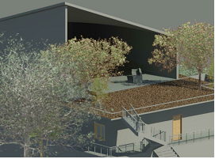

Commercial Project Overview
Under 21 Club
Our structure is an under 21 club which is located in Boulder, Colorado. This type of facility is not as common inland as it is in coastal cities, which is why we decided on our location. This is a three-story building (one level underground) that incorporates a dance floor, lounging space, and arcade for teenagers to enjoy. We are utilizing open space and the mountainous scenery with the use of glass walls and plenty of porch space.
When conducting our client survey, we found what teenagers of various ages would like to see in an under 21 club. We found that while the males surveyed were more concerned with food and video games, the females wanted lots of dancing and live music, along with refreshments. As for the aesthetics, those surveyed wanted a modern styled building.
The style and merits of the design concepts were to appeal to a younger generation and reflect the area in which it is located. The basement floor was designed to include video games, pool tables, and the office for management. The main floor will serve the purpose of the dance floor, kitchen/refreshments area, and the dj booth. The top floor has a lounge area which includes couches and televisions, along with a green roof area that will serve as an outdoor lounge/porch space. All of these elements will combine to create a uniform and aesthetically appealing structure.
As earlier mentioned, our architecture style is modern. This style is based on the use of metal, glass, and concrete with sharp edges, and an overall blocky or simple look. We will incorporate this style by our use of materials and design. Through the use of glass curtain walls, sharp edges, and a simple overall look, our building effectively conveys the style we chose.
Our building includes a green roof and a retention pond, which are sustainable design aspects. These help with water runoff. Our parking lot, which includes 45 parking spots, has 2 single islands and 2 double islands, which meet the required amount of green space for our building.

