STEAM vs. STEM in Education
Natalie Rowland
Waxahachie Global High School

Table of Contents
Abstract 3
Introduction 4
What is STEM? 4
STEM Career Outlooks 5
What is STEAM? 5
What STEAM Brings to the Labor Force 5
Why STEAM is the Way for Education to Proceed 7
Conclusion 8
References 9
Appendix A 11
Figure A1 Mathematics Literacy 11
Figure A2 Problem Solving 12
Figure A3 Reading Literacy 13
Figure A4 Science Literacy 14
Appendix B 15
Figure B1 Growth Expectation 15
Figure B2 STEM Field Division 15

Abstract
The current debate of STEM vs. STEAM has plagued the education system for approximately the last five years. In this debate, STEM is seen as the way to economic growth and success in careers, while STEAM advocates encourage the arts in order to develop social and cultural skills which appear to be declining over the course of STEM focus. Even political figures such as Rick Scott of Florida are on board with decreasing funds to the arts, saying that, “degrees that don’t offer a good return on investment…” aren’t vital to the economy. (STEM School, July 11, 2012.) However, arts advocates, such as Americans for the Arts, states that “…arts are essential. They teach students innumerable lessons – practice makes perfect, small differences can have large effects, collaboration leads to creativity. The arts also teach children that… all problems have more than one solution.” (Americans, n.d.) These two views both are acceptable, however, comparing them to the workforce shows that arts are necessary for enhanced cognitive functions are higher level achievement skill sets. When compared, STEM is needed for the shift in job growth and the economy, however, it’s also crucial to develop higher level skills that are not able to be substituted.
Keywords: STEM, STEAM, Arts, Education

Introduction
A large debate in education currently is whether STEAM (science, technology, engineering, arts, and math) or STEM (science, technology, engineering, and math) learning is better overall for students, their leaning abilities and their test scores. Since “the Obama administration announced the 2009 ‘Educate to Innovate’ campaign,” schools have been refocusing on what education entails at the elementary through secondary level (Hom, 2014). Within recent years, however, there has been an increased backing of the idea of STEAM, a program similar to STEM, but with the integration of arts included. This has caused friction between arts advocates and the full STEM advocates in the educational system, at all levels.
What is STEM?
STEM is a curriculum movement towards an emphasis in left brain activities, as well as their applications in real life situations and the work place. (STEM School, Dec., 2012). According to the Program for International Student Assessment 2012 assessment, the United States is 35th in mathematics literacy, 27th in science literacy, and 25th in reading literacy (National, 2012). These records, as well as the records for 2006 and 2009 where the original cause of the STEM program emphasis, with the worrying effect that the U.S. was falling behind in its educational standards. According to the U.S. Department of Education, “nearly 28 percent of high school freshman declare an interest in a STEM-related field, …but 57 percent of these students will lose interest by the time they graduate from high school” (2014). This means that out of a class of 1,000, over one-fourth of students, will begin their education interested in a STEM career path, however, after four years of education, that number will dwindle to less than a fifth of the total number of students. These combined factors worry U.S. leaders, as they continue to fumble to regain lost education in students. See Appendix A for the PISA graphs and statistics.
STEM Career Outlooks
In a classic education, there is general priority over all subjects, and usually no engineering or high level technology involved. However, with the changing of employment needs and wants, technology, engineering, and science inputs are all necessary. According to the Economics & Statistics Administration, STEM fields have three times the projected growth and opportunity outlook of non-STEM careers. They also make an average 26% more income than those who are not in a STEM career (Economics, n.d.). In the expected division of STEM careers, computing and traditional engineering rank highest, with 71% and 16% respectively. (Hom, 2014). These careers are predicted to be the most populated by 2018. However, when looking at the expectations of STEM job growth, it is found that the constant job growth rate between the years 2010 and 2020, for all careers, not only STEM is about 14%. However, the expected job growth of software developers is at 32%, medical scientists at 36% and biomedical engineering at 62%. This outlook shows that an education and background in STEM is highly encouraged in the work force and even necessary for many careers. However, within STEM fields, a gap is found where creativity and innovation are not encouraged at earlier stages. Children and young adults that are not involved with arts early on have more trouble with innovative and creative approaches than those who have experience with the arts. Appendix B shows the charts with division data and growth expectation.
What is STEAM?
The idea of STEAM is to bring “art and design to the center of STEM” (STEM School, July 11, 2012). The idea is that the U.S. is regaining momentum, and innovation is everywhere, but adding arts at the center could increase the economic proficiency of the country. The motion was originally introduced by the Rhode Island School of Design, and brings three key ideas into the STEM program, according to the STEM to STEAM organization, those three elements are as follows.
- Transform research policy to place art and design at the center of STEM
- Encourage integration of art and design in the K-20 education
- Influence employers to hire artists and designers to drive innovation (STEM to STEAM, n.d.)
A key group involved in the STEAM initiative is Americans for the Arts, a group who claims that
Arts education has undeniable benefits: stimulates and develops the imagination and critical thinking, refine cognitive and creative skills, has positive effects development growth, strengthens problem-solving skills, increases the quality of task performance, helps develop informed perception, self-confidence, and helps with team-building skills, respecting various viewpoints and appreciating culture and tradition (STEM School, July 11, 2012).
What a STEAM Education Brings to the Labor Force
As Americans for Arts said, there are beneficial aspects to the character of a person from participating in an art program. The self-confidence, and cultural aspects which art offers cannot be replaced with any subsidy, save real world experience. STEAM influence in careers can offer benefits like “...visualization, which empowers science research just as it does science education… and free[ing] the scientist’s and engineer’s mind[s].” (Storksdieck, 2011). These qualities are vital in the projected careers the U.S will need, such as environmental engineers, programmers, software developers, and biomedical engineers, to name a few. Take note that all of these careers combine the workings of STEM with the creative mind of an artist. The artistic mind feeds into creative solutions in the workforce, which might not have been available otherwise.
The inclusion of arts is something that cannot be taught at the collegiate level, and must be mixed the upbringing of a student, and potential work force member, as they go about their education. According to the Valerie Strauss, a Washington Post correspondent and Lisa Phillips, of Americans for Arts, “… in an increasingly competitive world, where people are being asked to continually develop new skills, perseverance is essential to achieving success.” (Strauss, 2013). The excerpt goes on to talk about how perseverance is a trait earned through constructive criticism and continuously working towards achievement in the arts. Phillips also mentions that collaboration and dedication are two skills which are developed in the arts and are invaluable to success in the work place.
Why STEAM is The Way for Education to Proceed
With the increasing amount of STEM fields, arts should be falling aside to preparations for these careers. This idea is flawed, as the arts are a key to versatility and problem solving techniques. Art shows a way around obstacles, using specific criteria and constraints, much like an engineering brief would. As Americans for Arts said, “Research has shown impressive benefits of arts education on an entire culture – especially student motivation, attitudes, and attendance… arts education encourage[s] students to stay in school, succeed in school, succeed in life, and succeed in work.” (Americans, n.d.) With this view, it is the combination of STEM with arts that leads to more success. When viewing statistics on the curriculum in the U.S. compared to countries such as Singapore and Japan, top ten performers in all categories of the PISA, culture and arts knowledge are core classes added to those that the U.S. has. Japan, for example, requires students “…to take courses in Japanese, Social Studies, Mathematics, Science, Music, Art, Physical Education, Home Economics and English…” through at least their junior high school education (Mejiro, n.d.). As for Singapore’s students, the emphasis is on foreign language, with arts being introduced at later points. In comparison overall, the U.S. is behind because we try to single out programs and mistakes in the individual subjects, when the problem is an overall lacking in communication and mingling between interdisciplinary achievement. To regain lost education, it is crucial to reintegrate arts and language into education for their benefits outside of Arts alone.
Conclusion
The rift in education is obvious; do arts matter or do they not? To some the answer is no, they’re just a hindrance to a valid and useful education, however, to others the answer is yes, arts are a valid point which must be incorporated into everyday schooling. The majority of research of what makes successful people is found in what they’ve done not only in their schooling, but also in how much of the arts they’ve been exposed to. Yes, STEM is the correct route to the United States’ future success, there just happens to be an “A” bunched into it as well, to create the power that is an education of STEAM.

References
Americans for the Arts. (n.d.). Arts education. Retrieved from http:// www.americansforthearts.org/by-topic/arts-education
Economics & Statistics Administration. (n.d.) STEM: Good jobs now and for the future. Retrieved from http://www.esa.doc.gov/Reports/stem-good-jobs-now-and-future
Hom, Elaine J. (2014, Feb 11). What is STEM education?. Retrieved from http://
www.live science.com/43296-what-is-stem-education.html
Mejiro Gakuen Educational Foundation. (n.d.). The curriculum. Retrieved from http:// www.mejiro.ac.jp/eng/highschool/curriculum.html
National Center for Education Statistics. (n.d). Program for International Student Assessment (PISA). Retrieved from http://nces.ed.gov/surveys/pisa/pisa2012/
pisa2012highlights _3_1.asp
STEM School. (2012, July 11). What about STEAM education?. Retrieved from http://
www. stemschool.com/articles/what-about-steam-education/
STEM School. (2012, Dec 09). What is STEM education. Retrieved from http://
www.stem school.com/articles/what-is-stem-education/
STEM to STEAM. (n.d.) Retrieved from http://stemtosteam.org/
Storksdieck, Martin. (2011, Apr 1). STEM or STEAM?. Retrieved from http://scienceblogs.com/ art_of_science_learning/2011/04/01/stem-or-steam/
Strauss, Valerie. (2013, Jan 22). Top 10 skills children learn from the arts. Retrieved from http://www.washingtonpost.com/blogs/answer-sheet/wp/2013/01/22/
top-10-skills-children-learn-from-the-arts/
U.S. Department of Education. (2011). Science, technology, engineering and math: Education for global leadership. Retrieved from http://www.ed.gov/stem

Appendix A
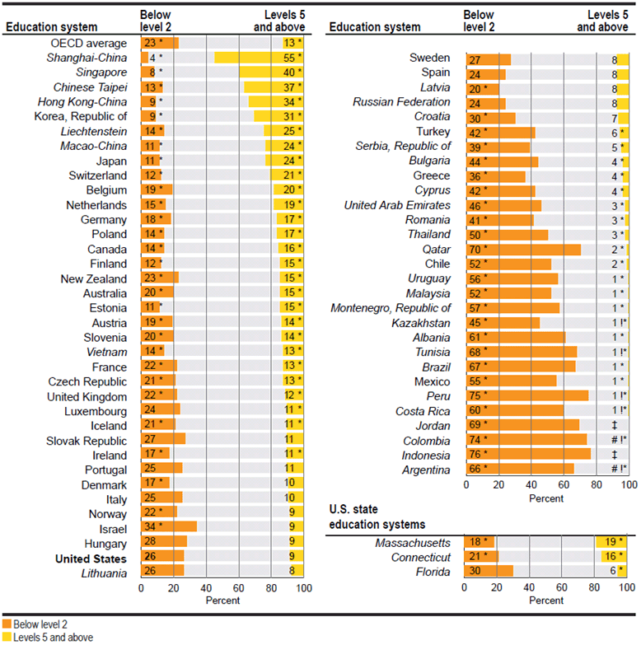
Figure A1 Mathematics Literacy

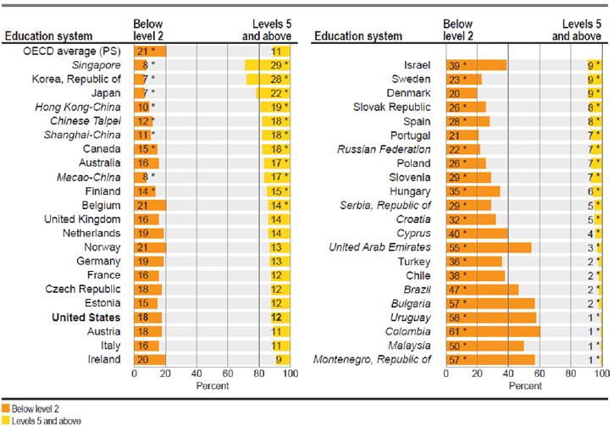
Figure A2 Problem Solving

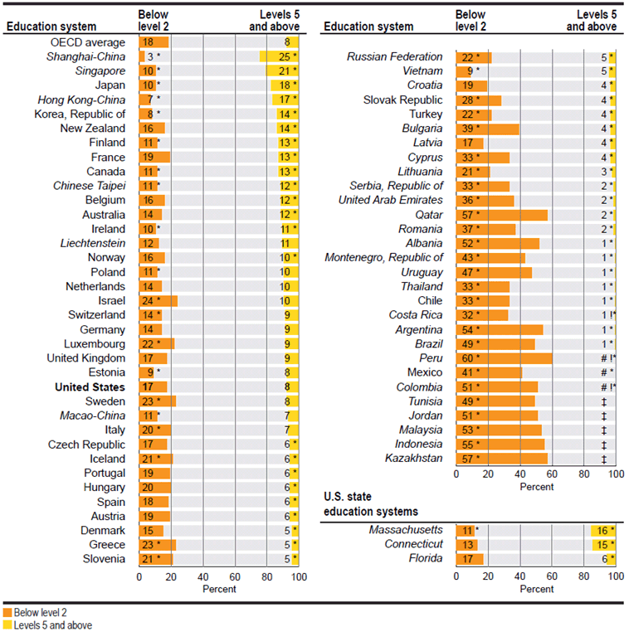
Figure A3 Reading Literacy

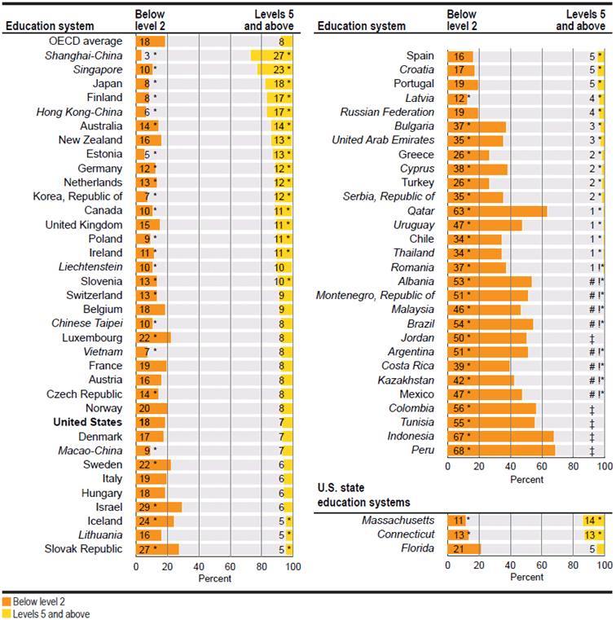
Figure A4 Science Literacy

Appendix B
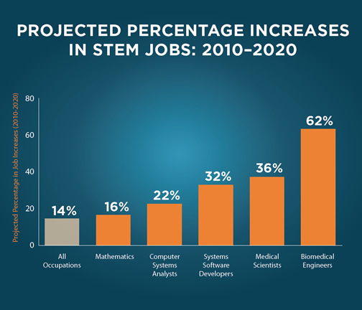
Figure B1 Growth Expectations

Figure B2 STEM Field Division

